Experiment 1a: Install Flutter and Dart SDK
Aim
To install Flutter and Dart SDK on your local machine.
System Requirements
Hardware Requirements
To install and run Flutter, your Windows environment must meet the following hardware requirements:
Requirement | Minimum | Recommended
x86_64 CPU Cores | 4 | 8
Memory in GB | 8 | 16
Display resolution in pixels | WXGA (1366 x 768) | FHD (1920 x 1080)
Free disk space in GB | 11.0 | 60.0

Software Requirements
To write and compile Flutter code for Android, you must have the following version of Windows and the listed software packages.
Tip: You do not need to install Dart separately as the Flutter SDK includes the full Dart SDK.
Operating System
Flutter supports 64-bit version of Microsoft Windows 10 or later. These versions of Windows should include the required Windows PowerShell 5 or later.
Development Tools
Download and install the Windows version of the following packages:
- Git for Windows 2.27 or later to manage source code.
- Android Studio 2023.3.1 (Jellyfish) or later to debug and compile Java or Kotlin code for Android. Flutter requires the full version of Android Studio.
The developers of the preceding software provide support for those products.
When you run the current version of flutter doctor, it might list a different version of one of these packages. If it does, install the version it recommends.
Configure a Text Editor or IDE
You can build apps with Flutter using any text editor or integrated development environment (IDE) combined with Flutter's command-line tools.
Using an IDE with a Flutter extension or plugin provides code completion, syntax highlighting, widget editing assists, debugging, and other features.
Popular options include:
- Visual Studio Code 1.77 or later with the Flutter extension for VS Code.
- Android Studio 2023.3.1 (Jellyfish) or later with the Flutter plugin for IntelliJ.
Procedure
Step 1: Download Flutter SDK
- Visit the Flutter official website.
- Choose your operating system (Windows, macOS, Linux).
- Download the Flutter SDK zip file.
Step 2: Extract Flutter SDK
- Extract the downloaded zip file to a desired location on your system.
- Add the flutter/bin directory to your system's PATH environment variable.
Step 3: Verify Installation
- Open a command line interface.
- Run the command:
flutter doctor
- Follow any additional setup instructions provided by flutter doctor.
Step 4: Install Dart SDK
- Dart SDK is bundled with Flutter, so no separate installation is required.
- Verify Dart installation by running:
dart --version
Conclusion
You have successfully installed Flutter and Dart SDK on your machine. You are now ready to start developing Flutter applications.

1 b)Write a simple Dart program to understand the language basics.
void main() {
// Variables
var name = 'Srinivas';
int age = 20;
double height = 5.9;
bool isAdult = age > 18 ? true : false;

// Print statements
print('Name: $name');
print('Age: $age');
print('Height: $height');

// Conditional statement
if (isAdult) {
print('$name is an adult.');
} else {
print('$name is not an adult.');
}

// Function call
greet(name);

// Loop
for (int i = 1; i <= 5; i++) {
print('Loop iteration $i');
if (i == 3) {
break;
}
}

// Friends array
List<String> friends = ['Bhanu', 'Amar', 'Amulya', 'Kiran', 'Sandeep'];

// Looping through the friends array
for (String friend in friends) {
print('Hello, $friend!');
}

// Creating an object of the Person class
Person person = Person(name, age, height);
person.introduce();

// Exception handling
try {
// Code that may throw an exception
int result = 10 ~/ 0; // Floor division by zero
print('Result: $result');
} catch (e) {
// Handling the exception
print('An error occurred: $e');
}
}

// Function definition
void greet(String name) {
print('Welcome to SDC, $name!');
}

// Class definition
class Person {
String name;
int age;
double height;
bool isAdult;

// Constructor
Person(this.name, this.age, this.height) : isAdult = age > 18;

// Method
void introduce() {
print(
'My name is $name, I am $age years old and my height is $height feet.');
}

}

Experiment 2:
- a) Explore various Flutter widgets (Text, Image, Container, etc.). Text Widget:
import 'package:flutter/material.dart'; void main() {
runApp(MyApp());
}
class MyApp extends StatelessWidget { @override
Widget build(BuildContext context) { return MaterialApp(
home: Abc();
);}}
class Abc extends StatelessWidget { const Abc({super.key});
@override
Widget build(BuildContext context) { return Scaffold(
appBar: AppBar(title: Text('Text Widget Example')), body: Center(
child: Text(
'Hello, Flutter!',
style: TextStyle(fontSize: 24, fontWeight: FontWeight.bold),
),
),
),}}

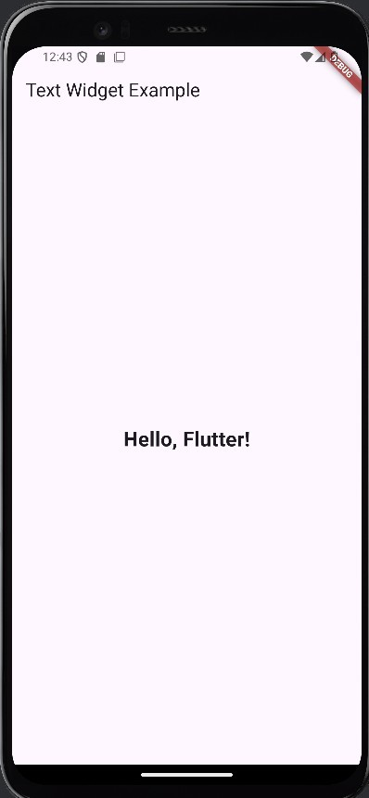

IMAGE WIDGET

void main() {
runApp(const MainApp()); // Run the MainApp widget as the root of the application
}

class MainApp extends StatelessWidget {
const MainApp({super.key}); // Constructor for the MainApp widget

@override
Widget build(BuildContext context) {
return MaterialApp( // Create a MaterialApp widget
home: Scaffold(
body: Center(
child: Column(
mainAxisAlignment: MainAxisAlignment.center, // Center the column vertically
children: [
const Text( // Display a text widget with the given text
'Welcome to Flutter!',
style: TextStyle(fontSize: 24),
),
const SizedBox(height: 16),
Image.asset( // Display an image from the assets folder
'assets/images/flutter_logo.png',
width: 200, // Set the width, height of the image
height: 200,
),
const SizedBox(height: 16),
Container( // Create a container widget
width: 200,
height: 50,
color: Colors.blue, // Set the background color of the container
child: const Center(
child: Text( // Display a text widget
'Start',
style: TextStyle(color: Colors.white), // Set the text color
),
),
),
],
),
),
),
);
}
}

- Open the pubspec.yaml file in your Flutter project and add the following lines after flutter: to include the image asset in your project:
flutter:
uses-material-design: true
assets: <-- Add this line
- assets/images/flutter_logo.png <-- Add this line
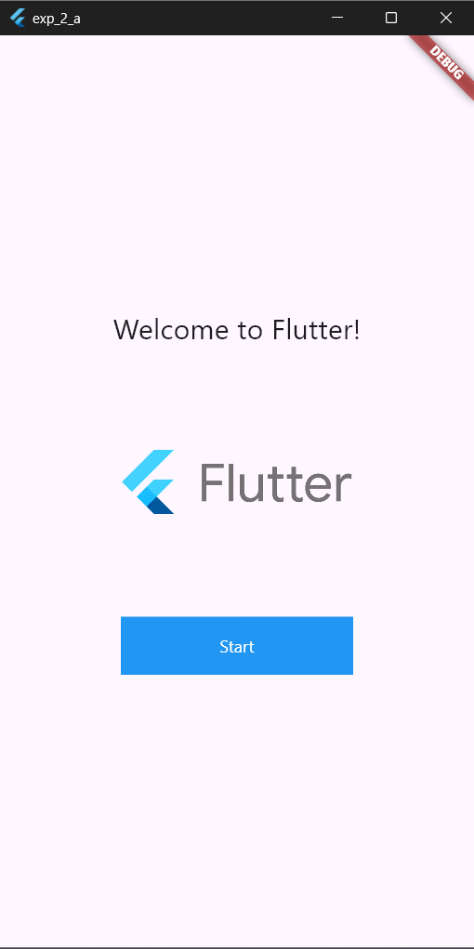

Container Widget
import 'package:flutter/material.dart';
void main() { runApp(MyApp());
}
class MyApp extends StatelessWidget { @override
Widget build(BuildContext context) { return MaterialApp(
home: Abc(),
);
}
}
class Abc extends StatelessWidget { const Abc({super.key});
@override
Widget build(BuildContext context) { return Scaffold(
appBar: AppBar(title: Text('Container Widget Example')), body: Center(
child: Container( width: 200,
height: 200,
padding: EdgeInsets.all(16), margin: EdgeInsets.all(16), decoration: BoxDecoration(
color: Colors.blue,
borderRadius: BorderRadius.circular(8), boxShadow: [
BoxShadow(
color: Colors.black26,
blurRadius: 10,
offset: Offset(2, 2),
),
],
),
child: Center( child: Text(
'Container',
style: TextStyle(color: Colors.white, fontSize: 24),
),
),
),
),
);
}
}
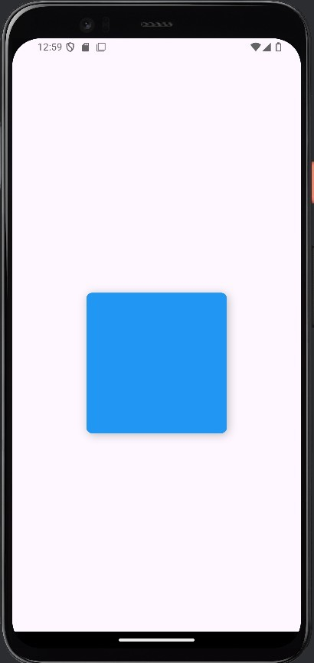

Card Widget

import 'package:flutter/material.dart';
void main() { runApp(MyApp());
}

class MyApp extends StatelessWidget { @override
Widget build(BuildContext context) { return MaterialApp(
home: Abc();
);
}
}

class Abc extends StatelessWidget { const Abc({super.key});

@override
Widget build(BuildContext context) { return Scaffold(
appBar: AppBar(title: Text('Card Widget Example')), body: Center(
child: Card(
elevation: 5, // The shadow effect of the card shape: RoundedRectangleBorder(
borderRadius: BorderRadius.circular(10), // Rounded corners
),
child: Container( width: 300,
height: 150,
padding: EdgeInsets.all(16), child: Column(
mainAxisAlignment:MainAxisAlignment.center,
children: [ Text(
'Card Title',
style: TextStyle(fontSize: 24, fontWeight: FontWeight.bold),
),
SizedBox(height: 10), Text(
'This is a card description. Cards can be used to display related

information.',

textAlign: TextAlign.center, style: TextStyle(fontSize: 16),
),

],
),
),
),
),
);
}
}

2 b) Implement different layout structures using Row, Column, and Stack widgets.
import 'package:flutter/material.dart';

void main() {
runApp(const MainApp());
}

class MainApp extends StatelessWidget {
const MainApp({super.key});

@override
Widget build(BuildContext context) {
return const MaterialApp(
home: Scaffold(
body: LayoutApp(),
),
);
}
}

class LayoutApp extends StatelessWidget {
const LayoutApp({super.key});

@override
Widget build(BuildContext context) {
return Column(
mainAxisAlignment: MainAxisAlignment.center,
children: [
const Text('I\'m in a Coloum and Centered. The below is a row.'),
const SizedBox(height: 20),
Row(
mainAxisAlignment: MainAxisAlignment.spaceEvenly,
children: [
for (var color in [Colors.red, Colors.green, Colors.blue])
Container(
width: 100,
height: 100,
color: color,
),
],
),
const SizedBox(height: 20),
Stack(
alignment: Alignment.center,
children: [
Container(
width: 300,
height: 200,
color: Colors.yellow,
),
const Text(
'Stacked on Yellow Box',
style: TextStyle(fontSize: 24, fontWeight: FontWeight.bold),
),
],
),
],
);
}
}

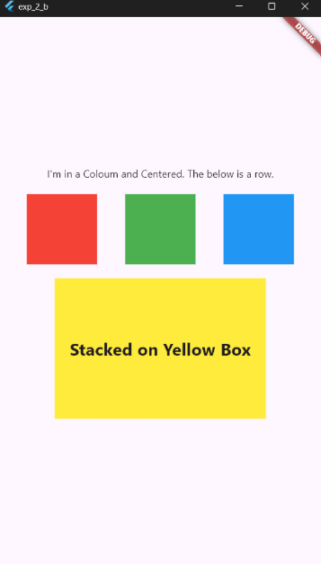
3. a) Design a responsive UI that adapts to different screen sizes.
import 'package:flutter/material.dart';

void main() {
runApp(const MainApp());
}

class MainApp extends StatelessWidget {
const MainApp({super.key});

@override
Widget build(BuildContext context) {
return const MaterialApp(
title: 'Responsive UI',
home: ResponsiveHomePage(),
);
}
}

class ResponsiveHomePage extends StatelessWidget {
const ResponsiveHomePage({super.key});

@override
Widget build(BuildContext context) {
return Scaffold(
appBar: AppBar(
title: const Text('Responsive UI'),
),
body: LayoutBuilder(
builder: (BuildContext context, BoxConstraints constraints) {
if (constraints.maxWidth >= 600) {
// For Wide Screen (Tablet/Desktop)
return _buildWideContainers();
} else {
// For Narrow Screen (Phone)
return _buildNarrowContainers();
}
},
),
);
}

Widget _buildWideContainers() {
return Container(
color: Colors.blue,
child: const Center(
child: Text(
'You are using a Wide screen!',
style: TextStyle(
fontSize: 26, color: Colors.white, fontWeight: FontWeight.bold),
),
),
);
}

Widget _buildNarrowContainers() {
return Container(
color: Colors.green,
child: const Center(
child: Text(
'You are using a Narrow screen!',
style: TextStyle(fontSize: 16, color: Colors.white),
),
),
);
}
}
3 b) Implement media queries and breakpoints for responsiveness.
import 'package:flutter/material.dart';

void main() {
runApp(const MyApp());
}

class MyApp extends StatelessWidget {
const MyApp({super.key});

@override
Widget build(BuildContext context) {
return const MaterialApp(
home: ResponsiveHomePage(),
);
}
}

class ResponsiveHomePage extends StatelessWidget {
const ResponsiveHomePage({super.key});

static const colorCodes = (
body: Color(0xFFF8E287), // Sweet Corn approx.
navigation: Color(0XFFC5ECCE), // Padua approx.
pane: Color(0XFFEEE2BC), // Chamois approx
);
static const _style = TextStyle(fontSize: 20, fontWeight: FontWeight.bold);
static const body = Center(child: Text('Body', style: _style));
static const navigation = Center(child: Text('Navigation', style: _style));
static const panes = Center(child: Text('Pane', style: _style));

@override
Widget build(BuildContext context) {
final screenWidth = MediaQuery.of(context).size.width;
return Scaffold(
appBar: AppBar(
title: () {
// immediately-invoked function expression (IIFE)
if (screenWidth < 600) {
return const Text('Responsive UI - Phone');
} else if (screenWidth < 840) {
return const Text('Responsive UI - Tablet');
} else if (screenWidth < 1200) {
return const Text('Responsive UI - Landscape');
} else {
return const Text('Responsive UI - Large Desktop');
}
}(),
),
body: () {
// immediately-invoked function expression (IIFE)
if (screenWidth < 600) { <-- breakpoint
return buildCompactScreen();
} else if (screenWidth < 840) { <-- breakpoint
return buildMediumScreen();
} else if (screenWidth < 1200) { <-- breakpoint
return buildExpandedScreen();
} else { <-- breakpoint
return buildLargeScreen();
}
}(),
);
}

Widget buildCompactScreen() {
return Column(
children: [
Expanded(
child: Container(color: colorCodes.body, child: body),
),
Container(height: 80, color: colorCodes.navigation, child: navigation),
],
);
}

Widget buildMediumScreen() {
return Row(
children: [
Container(width: 80, color: colorCodes.navigation),
Expanded(
child: Container(color: colorCodes.body, child: body),
),
],
);
}

Widget buildExpandedScreen() {
return Row(
children: [
Container(width: 80, color: colorCodes.navigation),
Container(width: 360, color: colorCodes.body, child: body),
Expanded(
child: Container(color: colorCodes.pane, child: panes),
),
],
);
}

Widget buildLargeScreen() {
return Row(
children: [
Container(color: colorCodes.navigation, width: 360, child: navigation),
Container(width: 360, color: colorCodes.body, child: body),
Expanded(
child: Container(color: colorCodes.pane, child: panes),
),
],
);
}
}

4a. Set up navigation between different screens using Navigator.
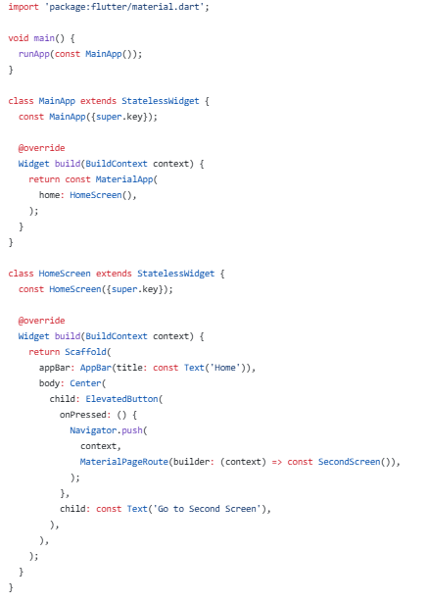
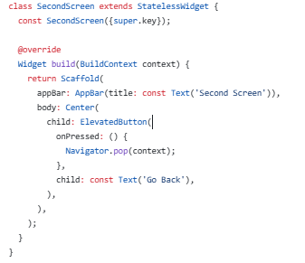

4 b) Implement navigation with named routes.
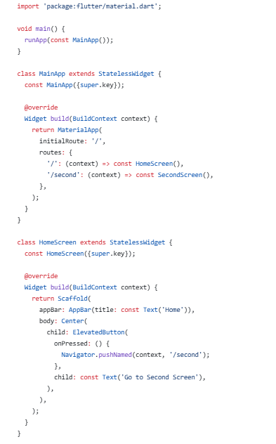
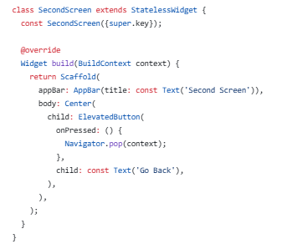

5. a) Learn about stateful and stateless widgets.
Stateless Widgets
Stateless widgets are immutable, meaning their properties can't change once they're built. They are typically used for widgets that don't require any mutable state (i.e., they don't change over time or in response to user interactions). Examples of stateless widgets include Text, Icon, and Container.
Structure:
- Stateless widget class that extends StatelessWidget.
- build() method that returns the widget's UI based on the input properties.
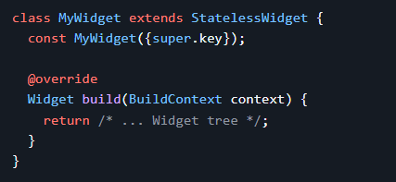
Example:
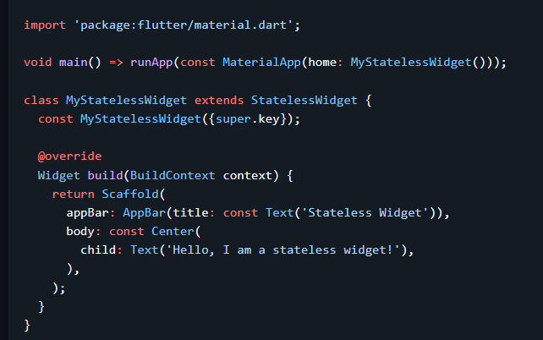
Output:
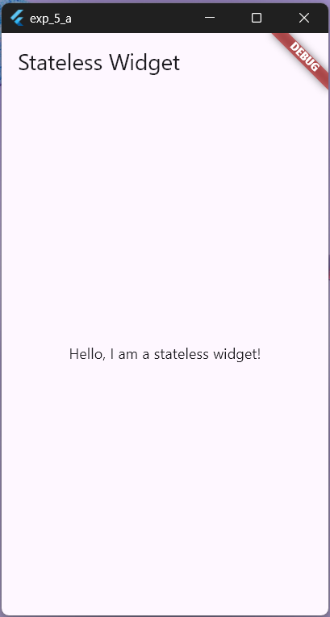
Stateful Widgets
Stateful widgets are dynamic and can change their state during their lifetime. They are used when the widget needs to update based on user interactions or other factors. Examples of stateful widgets include Checkbox, Radio, Slider, and TextField.
Stateful widgets consist of two classes:
- A StatefulWidget class that is immutable and can be used to create an instance of the widget.
- A State class that contains the mutable state for that widget.
Structure:
- StatefulWidget class that extends StatefulWidget.
- State class that extends State and manages the widget's mutable state.
- createState() method that creates an instance of the State class.
- build() method in the State class that returns the widget's UI based on the current state.
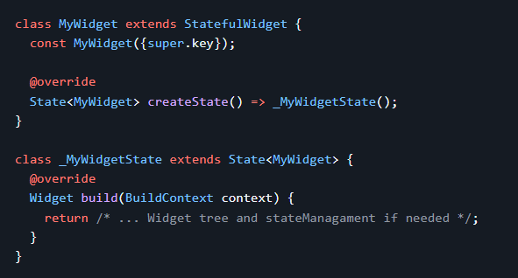
Example:
Output:
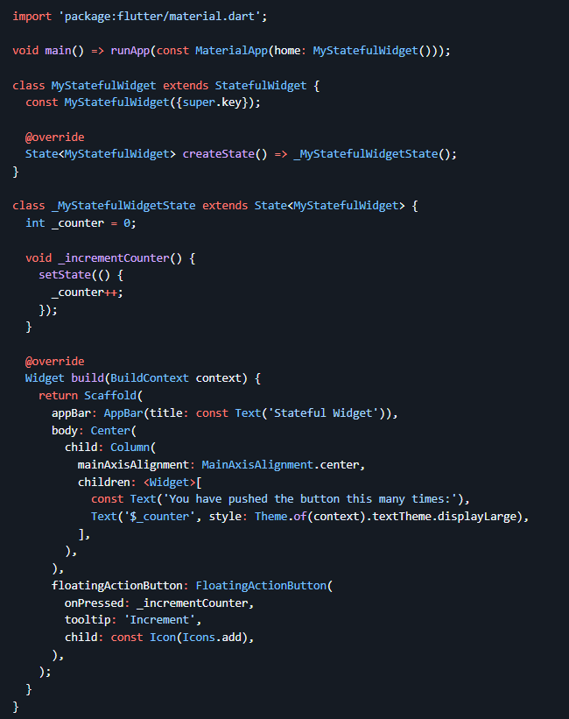
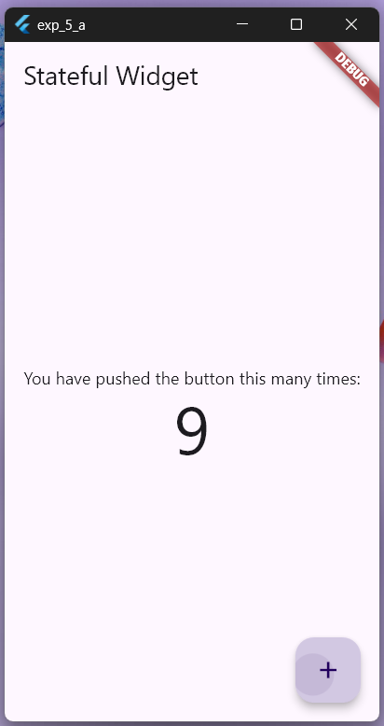

5 b) Implement state management using set State and Provider.
- Create a new Dart file called counter_model.dart in the lib directory of your Flutter project.
lib/counter_model.dart
Add the following code snippet to the counter_model.dart file:
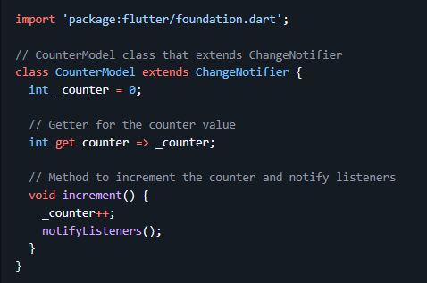
Save the file.
Open the lib/main.dart file in your Flutter project.
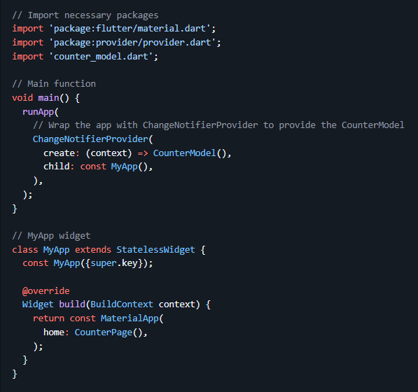
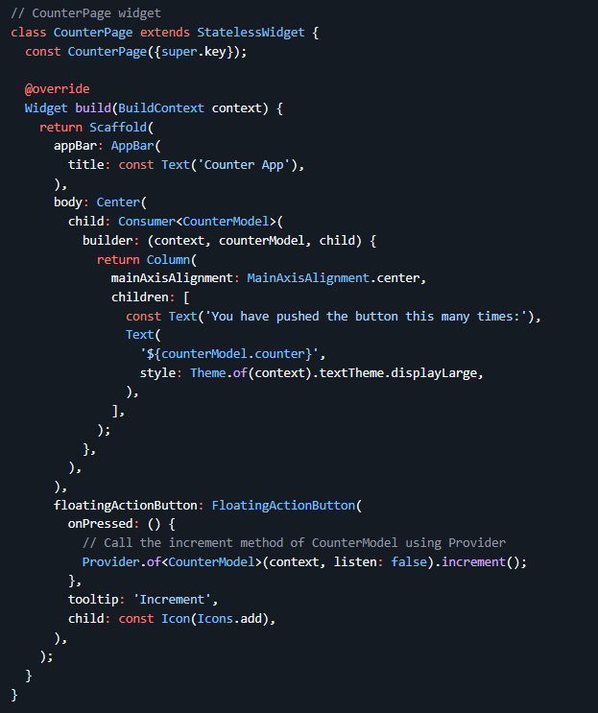

Save the file.

6a) Create custom widgets for specific UI elements.
import 'package:flutter/foundation.dart'; // Required for kDebugMode
import 'package:flutter/material.dart';

void main() {
runApp(const MyApp());
}

class MyApp extends StatelessWidget {
const MyApp({super.key});

@override
Widget build(BuildContext context) {
return MaterialApp(
home: Scaffold(
appBar: AppBar(title: const Text('Custom Button Widget')),
body: Center(
child: CustomButton(
text: 'Click Me',
icon: Icons.circle_outlined,
color: Colors.lightBlue[600],
onPressed: () {
if (kDebugMode) {
// Check if the app is running in debug mode
print('Button Pressed!');
}
},
), // CustomButton
), // Center
), // Scaffold
); // MaterialApp
}
}

// Custom Button Widget
class CustomButton extends StatelessWidget {
final String text;
final IconData icon;
final VoidCallback onPressed;
final Color? color, textColor;

const CustomButton(
{super.key,
required this.text,
required this.icon,
required this.onPressed,
this.color = Colors.blueAccent,
this.textColor = Colors.white});

@override
Widget build(BuildContext context) {
return ElevatedButton.icon(
onPressed: onPressed,
icon: Icon(icon, color: textColor),
label: Text(text, style: TextStyle(color: textColor)),
style: ElevatedButton.styleFrom(
backgroundColor: color,
shape: RoundedRectangleBorder(
borderRadius: BorderRadius.circular(8.0),
), // RoundedRectangleBorder
padding: const EdgeInsets.symmetric(horizontal: 16.0, vertical: 12.0),
),
); // ElevatedButton.icon
}
}

6b)Apply styling using themes and custom styles.
import 'package:flutter/material.dart';

void main() => runApp(const MainApp());

class MainApp extends StatefulWidget {
const MainApp({super.key});

@override
State<MainApp> createState() => _MainAppState();
}

class _MainAppState extends State<MainApp> {
bool isDarkTheme = false;

@override
Widget build(BuildContext context) {
return MaterialApp(
theme: isDarkTheme
? ThemeData.dark()
: ThemeData.light().copyWith(
colorScheme: ColorScheme.fromSeed(seedColor: Colors.redAccent)),
home: Builder(builder: (BuildContext context) {
return Scaffold(
appBar:
AppBar(title: Text(isDarkTheme ? 'Dark Theme' : 'Light Theme')),
body: Column(
// mainAxisAlignment: MainAxisAlignment.center, <-- Uncomment to center the widgets
children: <Widget>[
OutlinedButton.icon(
onPressed: () {},
label: const Text('Button'),
icon: isDarkTheme
? const Icon(Icons.dark_mode_rounded)
: const Icon(Icons.light_mode_rounded)),
const SizedBox(height: 20),
SwitchListTile(
title: const Text('Dark Theme'),
value: isDarkTheme,
onChanged: (value) {
setState(() {
isDarkTheme = value;
});
}),
]
),
);
}),
);
}
}

7. a) Design a form with various input fields.
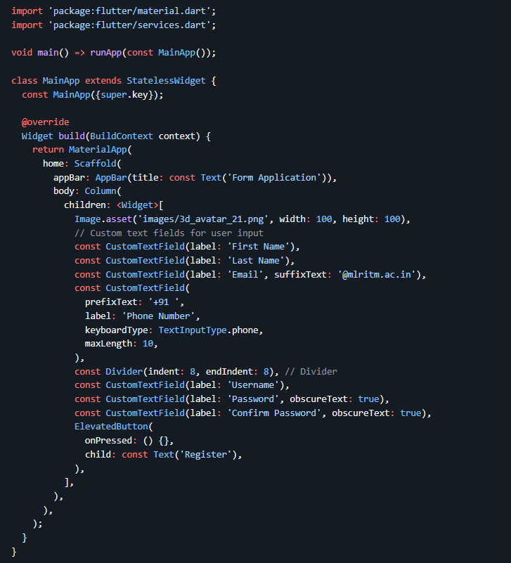
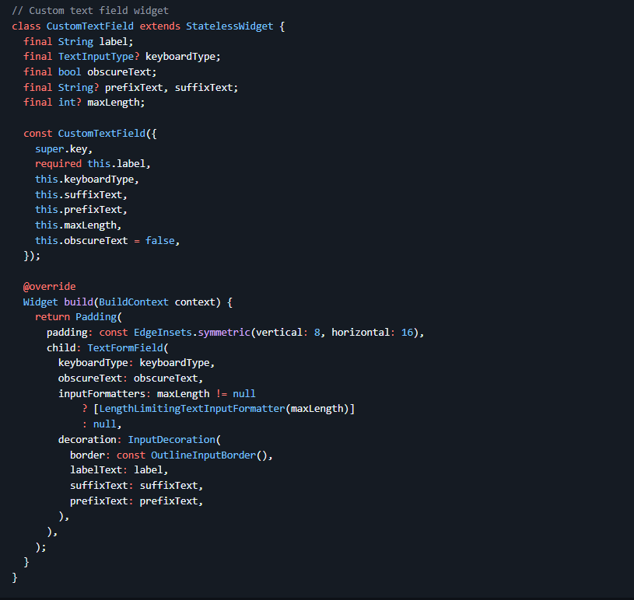
Open the pubspec.yaml file in your Flutter project and add the following lines after flutter: to include the image asset in your project:
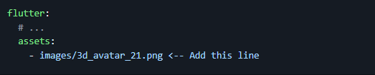

b) Implement form validation and error handling.
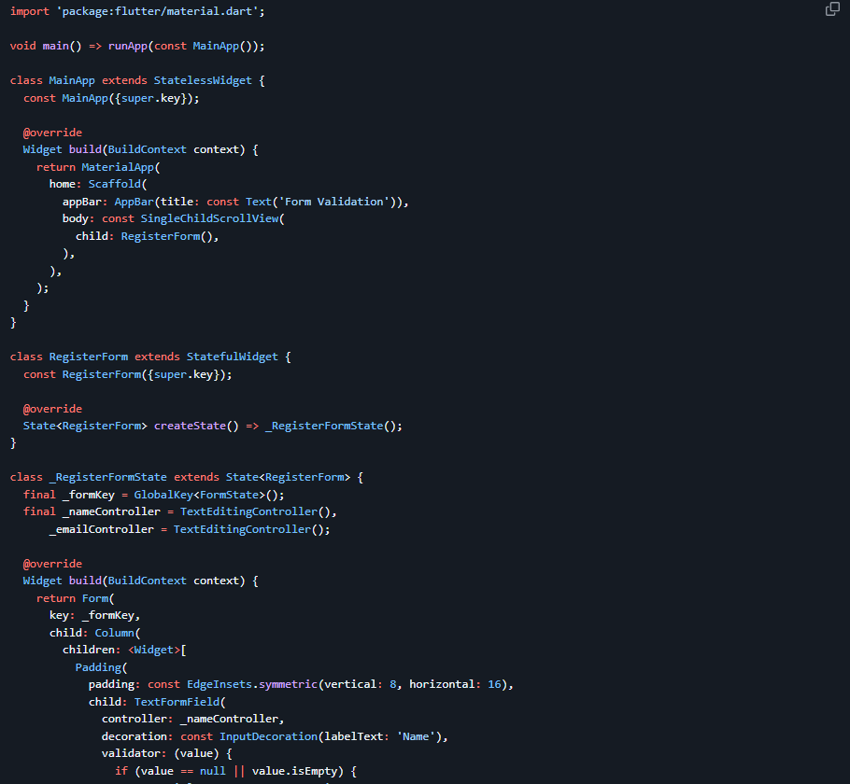
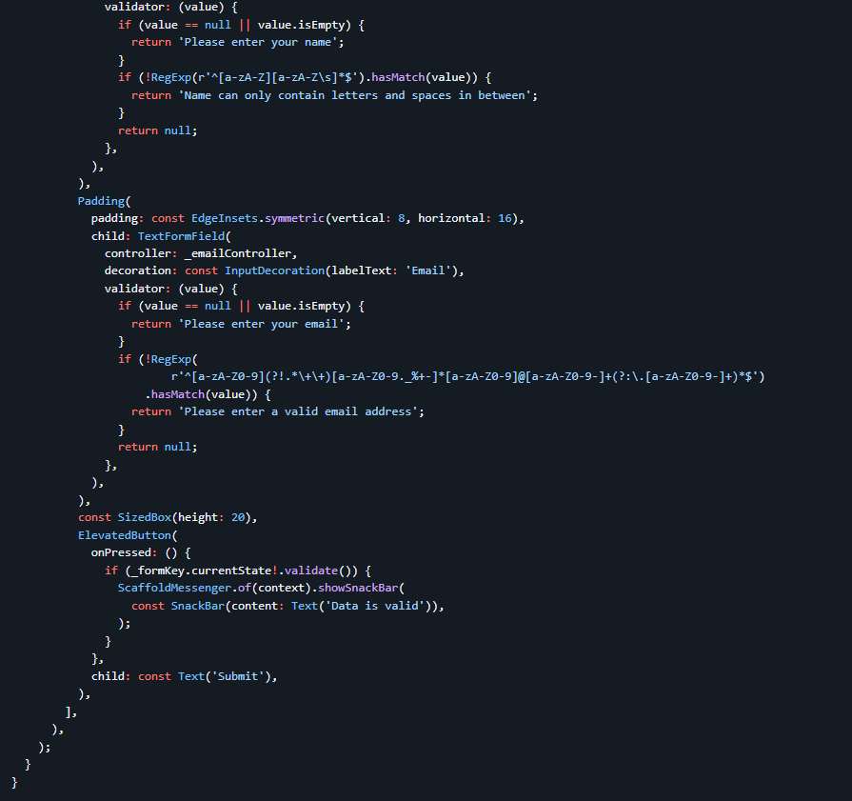

Experiment 8a:
Add animations to UI elements using Flutter’s animation framework.
import 'package:flutter/material.dart';

void main() => runApp(const MainApp());

class MainApp extends StatefulWidget {
const MainApp({super.key});

@override
State<MainApp> createState() => _MainAppState();
}

class _MainAppState extends State<MainApp> {
bool _isBig = false;

@override
Widget build(BuildContext context) {
return MaterialApp(
debugShowCheckedModeBanner: false,
home: Scaffold(
appBar: AppBar(
title: const Text('Beginner Animation'),
),
body: Center(
child: Column(
mainAxisAlignment: MainAxisAlignment.center,
children: [
const Text(
'Tap the box to animate',
),
GestureDetector(
onTap: () {
setState(() {
_isBig = !_isBig;
});
},
child: AnimatedContainer(
decoration: BoxDecoration(
borderRadius: BorderRadius.circular(8),
color: _isBig ? Colors.deepPurpleAccent : Colors.blueAccent,
),
duration: const Duration(seconds: 1),
curve: Curves.easeInOutBack,
width: _isBig ? 250 : 100,
height: _isBig ? 500 : 100,
alignment: Alignment.center,
child: const Text(
'Box',
style: TextStyle(
color: Colors.white, fontWeight: FontWeight.bold),
),
),
),
],
),
),
),
);
}
}

Experiment 8b
Experiment with different types of animations(fade,slide,etc)
import 'package:flutter/material.dart';

void main() {
runApp(const MyApp());
}

class MyApp extends StatelessWidget {
const MyApp({super.key});

@override
Widget build(BuildContext context) {
return const MaterialApp(
home: AnimationDemo(),
);
}
}

class AnimationDemo extends StatefulWidget {
const AnimationDemo({super.key});

@override
State<AnimationDemo> createState() => _AnimationDemoState();
}

class _AnimationDemoState extends State<AnimationDemo>
with TickerProviderStateMixin {
late AnimationController _scaleController;
late Animation<double> _scaleAnimation;
late AnimationController _fadeController;
late Animation<double> _fadeAnimation;
late AnimationController _slideController;
late Animation<Offset> _slideAnimation;
late AnimationController _rotateController;
late Animation<double> _rotateAnimation;
bool _visible = false;
bool _sliding = false;
bool _rotating = false;
bool _scaling = true;

@override
void initState() {
super.initState();

_fadeController = AnimationController(
vsync: this,
duration: const Duration(seconds: 1),
);
_fadeAnimation = Tween<double>(begin: 1, end: 0).animate(_fadeController);

_slideController = AnimationController(
vsync: this,
duration: const Duration(seconds: 1),
);
_slideAnimation = Tween<Offset>(
begin: const Offset(-1.0, 0.0),
end: const Offset(1.0, 0.0),
).animate(_slideController);

_rotateController = AnimationController(
vsync: this,
duration: const Duration(seconds: 2),
);
_rotateAnimation =
Tween<double>(begin: 0, end: 1).animate(_rotateController);

_scaleController = AnimationController(
vsync: this,
duration: const Duration(seconds: 2),
)..repeat(reverse: true);
_scaleAnimation = CurvedAnimation(
parent: _scaleController,
curve: Curves.easeInOut,
);
}

@override
void dispose() {
_scaleController.dispose();
_fadeController.dispose();
_slideController.dispose();
_rotateController.dispose();
super.dispose();
}

@override
Widget build(BuildContext context) {
return Scaffold(
appBar: AppBar(
title: const Text('Animation Demo'),
),
body: Center(
child: Column(
mainAxisAlignment: MainAxisAlignment.center,
children: [
FadeTransition(
opacity: _fadeAnimation,
child: SlideTransition(
position: _slideAnimation,
child: RotationTransition(
turns: _rotateAnimation,
child: ScaleTransition(
scale: _scaleAnimation,
child: const FlutterLogo(size: 100),
),
),
),
),
SwitchListTile(
title: const Text('Fade'),
value: _visible,
onChanged: (bool value) {
setState(() {
_visible = value;
_visible
? _fadeController.forward()
: _fadeController.reverse();
});
},
),
SwitchListTile(
title: const Text('Slide'),
value: _sliding,
onChanged: (bool value) {
setState(() {
_sliding = value;
_sliding
? _slideController.repeat(reverse: true)
: _slideController.stop();
});
},
),
SwitchListTile(
title: const Text('Rotate'),
value: _rotating,
onChanged: (bool value) {
setState(() {
_rotating = value;
_rotating
? _rotateController.repeat()
: _rotateController.stop();
});
},
),
SwitchListTile(
title: const Text('Scale'),
value: _scaling,
onChanged: (bool value) {
setState(() {
_scaling = value;
_scaling
? _scaleController.repeat(reverse: true)
: _scaleController.stop();
});
},
),
],
),
),
);
}
}

